Advanced Linux Lab

Date: 05-04-21

Name: RAJUL DUBEY

SAP ID: 500069424

**Task: 2.5 Sending a test email using standard SMTP commands**

**Requirements for this section** :

Ubuntu 14.04 VM and a user who has root privileges

**Steps:**

*#install mail utils apt-get install mailutils Let us send a test* **email from your machine:**

root@server: mail -s "This is the subject" xyz@abc.com <<< 'This is the message'

**Check the logs of the mail utility**

root@server: tail /var/log/mail.log

**Experiment**

1.) Need to run

**sudo apt-get update –fix-missing**

so that we can install mailutils package

2.) Run

**sudo apt-get install mailutils**

3.) Restart rsyslog service

**sudo service rsyslog restart**

4.) install postfix if it wasn’t installed with mailutils package

**sudo apt-get install postfix**

5.) Send the mail

**mail -s "This is the subject" xyz@abc.com <<< 'This is the message'**

6.) Check the mail log

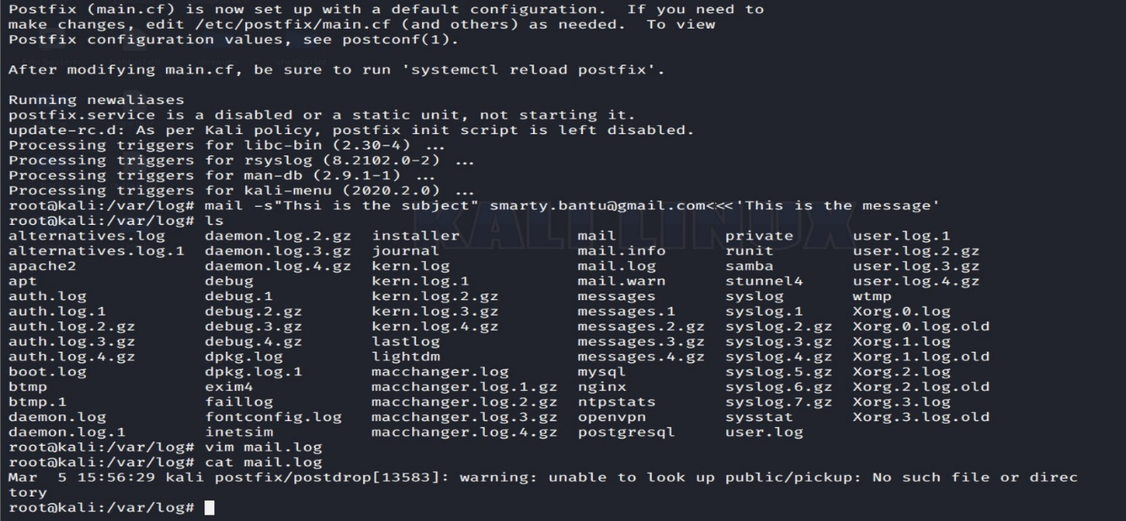 **cd tail /var/log/mail.log**